# Theme

# Android Estudio V3.0.17/Flutter

Objetivo:

F.Creación: 1-4-2018

Programa:

Fuente: [Theme](https://flutter.io/cookbook/design/themes/)

Con el objetivo de compartir colores y estilos de font a trabez de nuestra aplicación, podemos tomar ventaja de themes. Hay dos maneras de definir temas.App-wide o usando theme widget

Después de definir un tema , se usa con nuestros wiget

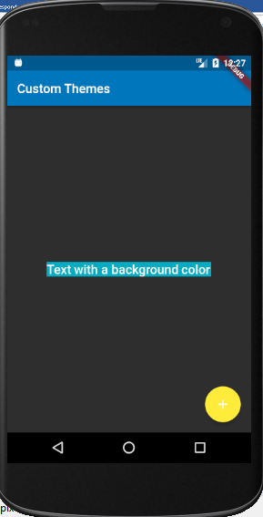

## Completo

**import 'package:flutter/foundation.dart'**;  
**import 'package:flutter/material.dart'**;  
  
**void** main() {  
 runApp(**new** MyApp());  
}  
  
**class** MyApp **extends** StatelessWidget {  
 @override  
 Widget build(BuildContext context) {  
 **final** appName = **'Custom Themes'**;  
  
 **return new** MaterialApp(  
 title: appName,  
 theme: **new** ThemeData(  
 brightness: Brightness.**dark**,  
 primaryColor: Colors.*lightBlue*[800],  
 accentColor: Colors.*cyan*[600],  
 ),  
 home: **new** MyHomePage(  
 title: appName,  
 ),  
 );  
 }  
}  
  
**class** MyHomePage **extends** StatelessWidget {  
 **final** String **title**;  
  
 MyHomePage({Key key, @required **this**.**title**}) : **super**(key: key);  
  
 @override  
 Widget build(BuildContext context) {  
 **return new** Scaffold(  
 appBar: **new** AppBar(  
 title: **new** Text(**title**),  
 ),  
 body: **new** Center(  
 child: **new** Container(  
 color: Theme.*of*(context).**accentColor**,  
 child: **new** Text(  
 **'Text with a background color'**,  
 style: Theme.*of*(context).**textTheme**.**title**,  
 ),  
 ),  
 ),  
 floatingActionButton: **new** Theme(  
 data: Theme.*of*(context).copyWith(accentColor: Colors.*yellow*),  
 child: **new** FloatingActionButton(  
 onPressed: **null**,  
 child: **new** Icon(Icons.*add*),  
 ),  
 ),  
 );  
 }  
}